Derivatives Questions Draft

1. Given the function defined by $f\left(x\right)=3x^{5}-20x^{3}$, find all values of $x$ for which the graph of $f$ is concave up.  
   (A) $x>0$  
   (B) $-\sqrt{2}<x<0$ or $x>\sqrt{2}$  
   (C) $-2<x<0$ or $x>2$  
   (D) $x>\sqrt{2}$  
   (E) $-2<x<2$
2. If $f\left(x\right)=x+\frac{1}{x}$, then the set of values for which $f$ increases is  
   (A) $\left(-∞,-1\right]∪\left[1,∞\right)$  
   (B) $\left[-1,1\right]$  
   (C) $\left(-∞,∞\right)$  
   (D) $\left(0,∞\right)$  
   (E) $\left(-∞,0\right)∪\left(0,∞\right)$
3. If $f\left(x\right)=\frac{ln x}{x}$, for all $x>0$, which of the following is true?
4. $f$ is increasing for all $x$ greater than 0 .
5. $f$ is increasing for all $x$ greater than 1 .
6. $f$ is decreasing for all $x$ between 0 and 1 .
7. $f$ is decreasing for all $x$ between 1 and $e$.
8. $f$ is decreasing for all $x$ greater than $e$.
9. At what values of $x$ does $f\left(x\right)=3x^{5}-5x^{3}+15$ have a relative maximum?  
   (A) -1 only  
   (B) 0 only  
   (C) 1 only  
   (D) -1 and 1 only  
   (E) $-1,0$ and 1
10. The graph of $y=\frac{-5}{x-2}$ is concave downward for all values of $x$ such that  
    (A) $x<0$  
    (B) $x<2$  
    (C) $x<5$  
    (D) $x>0$  
    (E) $x>2$
11. The absolute maximum value of $f\left(x\right)=x^{3}-3x^{2}+12$ on the closed interval $\left[-2,4\right]$ occurs at $x=$  
    (A) 4  
    (B) 2  
    (C) 1  
    (D) 0  
    (E) -2
12. If the graph of $y=x^{3}+ax^{2}+bx-4$ has a point of inflection at $\left(1,-6\right)$, what is the value of $b$?  
    (A) -3  
    (B) 0  
    (C) 1  
    (D) 3
13. The function $f$ given by $f\left(x\right)=x^{3}+12x-24$ is
14. increasing for $x<-2$, decreasing for $-2<x<2$, increasing for $x>2$
15. decreasing for $x<0$, increasing for $x>0$
16. increasing for all $x$
17. decreasing for all $x$
18. decreasing for $x<-2$, increasing for $-2<x<2$, decreasing for $x>2$
19. The derivative of $f$ is $x^{4}\left(x-2\right)\left(x+3\right)$. At how many points will the graph of $f$ have a relative maximum?  
    (A) None  
    (B) One  
    (C) Two  
    (D) Three  
    (E) Four
20. If $f\left(x\right)=x^{2}e^{x}$, then the graph of $f$ is decreasing for all $x$ such that  
    (A) $x<-2$  
    (B) $-2<x<0$  
    (C) $x≻2$  
    (D) $x<0$  
    (E) $x>0$
21. The graph of $y=3x^{4}-16x^{3}+24x^{2}+48$ is concave down for
$x<0$

$x>0$

22. $x<-2$ or $x≻\frac{2}{3}$
23. $x<\frac{2}{3}$ or $x>2$
$\frac{2}{3}<x<2$

24. The function $f$ given by $f\left(x\right)=3x^{5}-4x^{3}-3x$ has a relative maximum at $x=$  
    (A) -1  
    (B) $-\frac{\sqrt{5}}{5}$  
    (C) 0  
    (D) $\frac{\sqrt{5}}{5}$  
    (E) 1
25. What is the $x$-coordinate of the point of inflection on the graph of $y=\frac{1}{3}x^{3}+5x^{2}+24$?  
    (A) 5  
    (B) 0  
    (C) $-\frac{10}{3}$  
    (D) -5  
    (E) -10
26. A particle moves along the $x$-axis so that its position at time $t$ is given by $x\left(t\right)=t^{2}-6t+5$. For what value of $t$ is the velocity of the particle zero?  
    (A) 1  
    (B) 2  
    (C) 3  
    (D) 4  
    (E) 5
27. If $f^{''}\left(x\right)=x\left(x+1\right){\left(x-2\right)}^{2}$, then the graph of $f$ has inflection points when $x=$  
    (A) -1 only  
    (B) 2 only  
    (C) -1 and 0 only  
    (D) -1 and 2 only  
    (E) $-1,0$, and 2 only
28. The function $f$ is given by $f\left(x\right)=x^{4}+x^{2}-2$. On which of the following intervals is $f$ increasing?
$\left(-\frac{1}{\sqrt{2}},∞\right)$

$\left(-\frac{1}{\sqrt{2}},\frac{1}{\sqrt{2}}\right)$

$\left(0,∞\right)$

$\left(-∞,0\right)$

$\left(-∞,-\frac{1}{\sqrt{2}}\right)$

29. If $g$ is a differentiable function such that $g\left(x\right)<0$ for all real numbers $x$ and if $f^{'}\left(x\right)=\left(x^{2}-4\right)g\left(x\right)$, which of the following is true?
30. $f$ has a relative maximum at $x=-2$ and a relative minimum at $x=2$.
31. $f$ has a relative minimum at $x=-2$ and a relative maximum at $x=2$.
32. $f$ has relative minima at $x=-2$ and at $x=2$.
33. $f$ has relative maxima at $x=-2$ and at $x=2$.
34. It cannot be determined if $f$ has any relative extrema.
35. If $f$ is the function defined by $f\left(x\right)=3x^{5}-5x^{4}$, what are all the $x$-coordinates of points of inflection for the graph of $f$?  
    (A) -1  
    (B) 0  
    (C) 1  
    (D) 0 and 1  
    (E) $-1,0$, and 1
36. What is the derivative of $y=\sec{\sqrt{t}}$ ­?
$\sec{\sqrt{t}}\tan{\sqrt{t}}$

$\tan^{2}{\sqrt{t}}$

$\frac{\sec{\sqrt{t}}\tan{\sqrt{t}}}{2\sqrt{t}}$

$\sqrt{t}\tan^{2}{\sqrt{t}}$

37. At which $x$ coordinate is the tangent line to $y=3x^{2}-8x+12$ parallel to the line $4x + 2y = 7$?
    1. 0
    2. 1
    3. 2
    4. -2

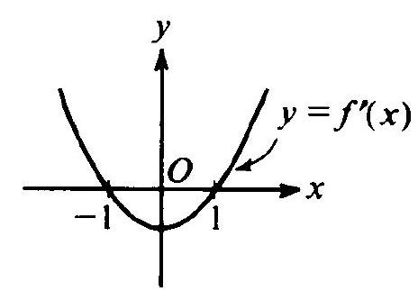

1. The graph of the derivative of $f$ is shown in the figure to the right. Which of the following could be the graph of $f$?

|  |  |  |
| --- | --- | --- |
| **A** | **B** | **C** |
| **D** | **E** |  |
|  |  |  |

1. 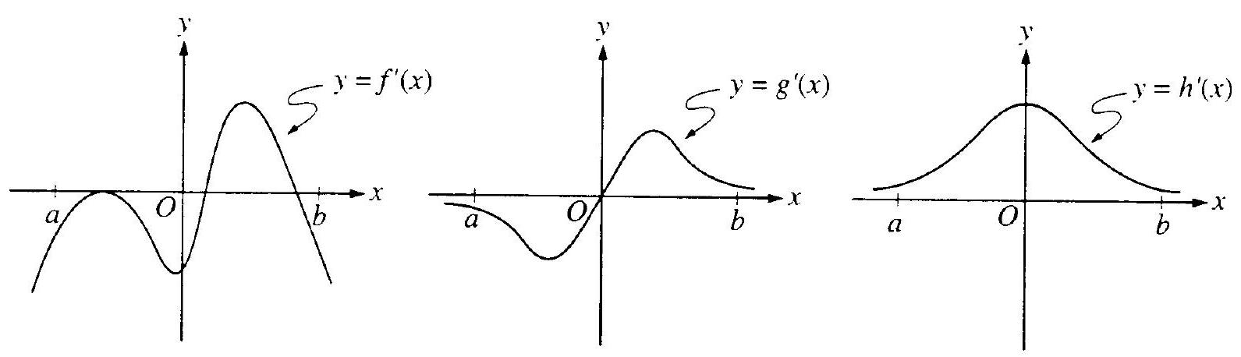The graphs of the derivatives of the functions $f,g$, and $h$ are shown below. Which of the functions $f,g$, or $h$ have a relative maximum on the open interval $a<x<b$?
2. $f$ only
3. $g$ only
4. $h$ only
5. $f$ and $g$ only
6. $f,g$, and $h$
7. 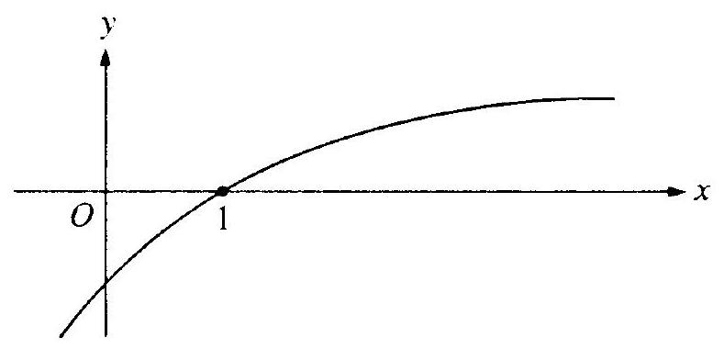The graph of a twice-differentiable function $f$ is shown in the figure below.   
     
     
   Which of the following is true?

$f(1)<f^{'}(1)<f^{''}(1)$

$f(1)<f^{''}(1)<f^{'}(1)$

$f^{'}(1)<f(1)<f^{''}(1)$

$f^{''}(1)<f(1)<f^{'}(1)$

$f^{''}(1)<f^{'}(1)<f(1)$

Free Response

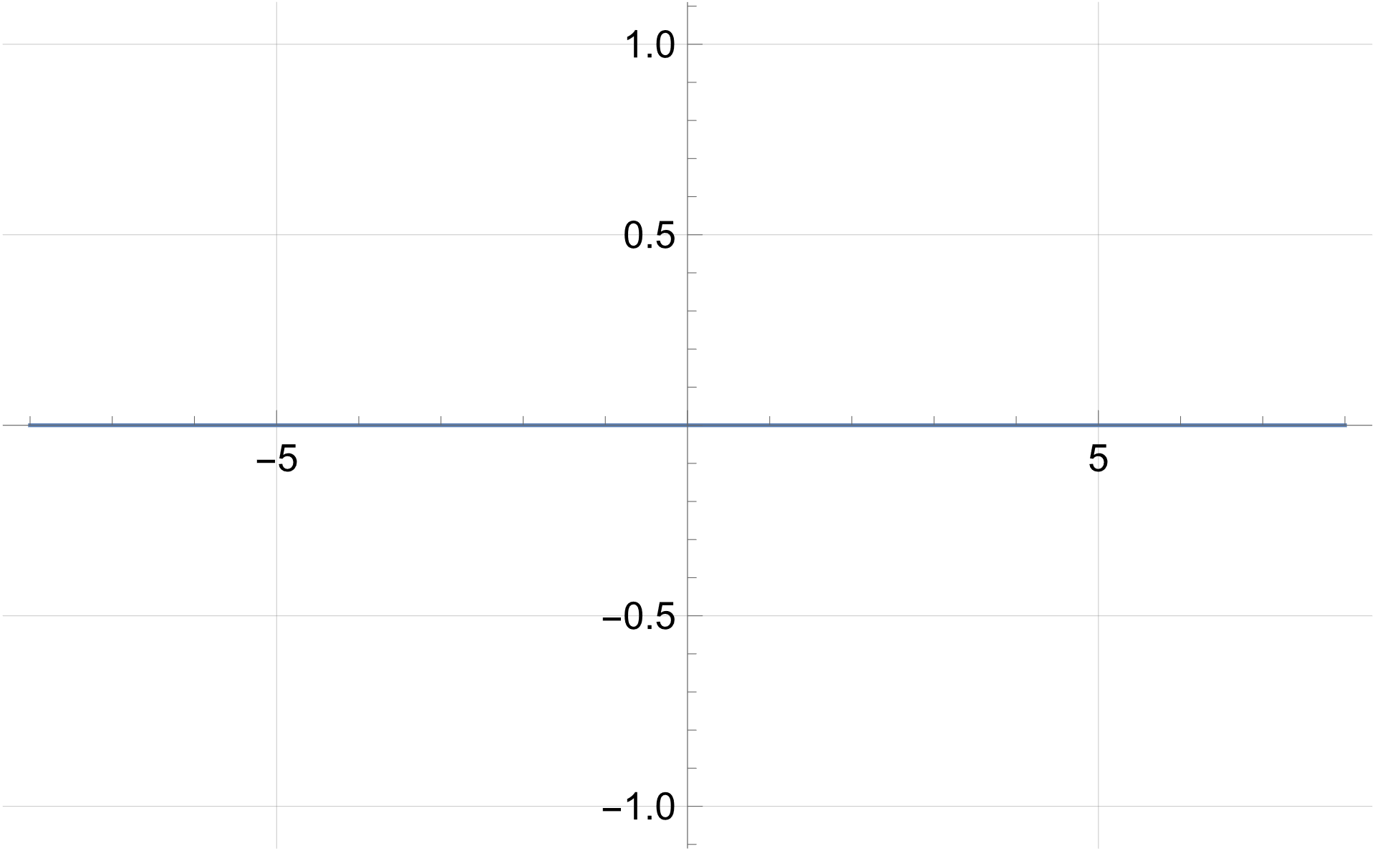The function $$f^{}\left(x\right)=\frac{1}{x^{2}-4}$$

has first derivative

$$f^{'}\left(x\right) =\frac{-2x}{{\left(x^{2}- 4\right)}^{2}}$$

and second derivative

$$f^{''}\left(x\right) =\frac{6 x^{2}+8}{{\left.\left(x^{2}- 4\right.\right)}^{3}}$$

**Sketch the graph of $f\left(x\right)$ after completing the following questions:**

1. State any domain restrictions for $f\left(x\right)$
2. Determine any critical points of $f\left(x\right)$
3. State intervals on which $f\left(x\right)$ is increasing or decreasing
4. State intervals on which $f\left(x\right)$ is concave up or concave down
5. Calculate any horizontal asymptotes of $f\left(x\right)$